Nepal College of Information Technology
Assessment
Spring 2011
Program : BE IT Time : 3 hrs
Semester : Spring (II) FM : 100
Subject : Electronic Device PM : 45

- Candidates are requested to give their answer as far as practicable in their own words.
- The figure in the margin indicates the full marks
- Attempt ALL question

1. a) Differentiate between linear and non-linear devices. Find the piecewise linear model of a Silicon diode with I_{S} = 10⁻¹¹ A and η = 1.6 in the vicinity of operating point I_{D} = 1 mA at 30 °C. (4+4)
b) What is reverse recovery time of PN junction diode? Explain its effect in diode switching with appropriate waveform. (7)
2. a) Draw the I-V characteristics of a PN junction diode showing forward biased region, reverse biased region and breakdown region. Differentiate between the two types of breakdown observed in PN junction diode. (5+3)
b) Refer the circuit diagram below:
Find: 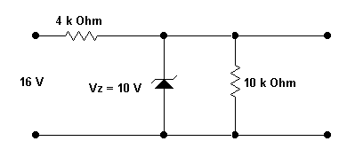 (2+2+3)
i) The output voltage.
ii) Voltage across R_{s} = 4 KΩ
iii) The current through Zener diode
3. a) Why BJT is said to be bipolar device and JFET as unipolar device? Explain the input and output characteristics of a common base configured BJT. (2+5)
b) Draw DC load line and locate the operating point of the following BJT circuit. (8)
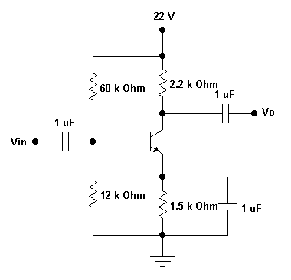
4. a) For the following configuration, find i) r_{e} and ii) voltage gain (A_{v}). (3+4)
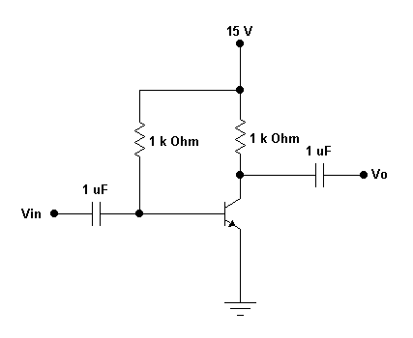
b) The transistor used in the circuit has the following parameters: h_{ie} = 1560 ohm, h_{fe} = 120. Calculate (i) R_{in(s),} (ii) R_{o}, (iii) A_{v} and (iv) A_{i}. (2+2+2+2)
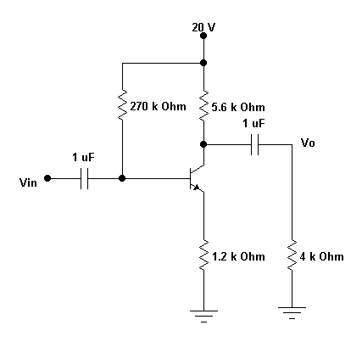
5. a) Describe the construction and working principle of an n-channel JFET with suitable diagrams. (8)
b) For the given JFET circuit, find the value of resistance R_{s}. Given: V_{GS} = -2 V. (7)
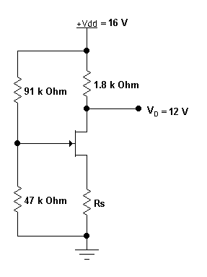

6. a) Explain the working principle of a full wave rectifier using a center tapped transformer. Find an expression for the ripple voltage when a filter capacitor is added in the full wave rectifier circuit. (4+4)
b) Draw the output waveform for the given circuits for the input sinusoidal signal having Vp = 12 V. (7)
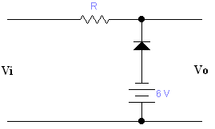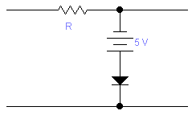

7. Write short notes on: (Any two) (5*2=10)
a) Transition region capacitance and Diffusion region capacitance
b) High frequency T-model of BJT
c) Ebers Moll model of BJT
d) Thermal runaway and bias compensation

